Create the database EMPLOYEESDB with the tables DEPARTMENTS and EMPLOYEES from EMPLOYEESDB.sql

Do the following queries:

**1.** Show the last name, occupation and department number of each employee.

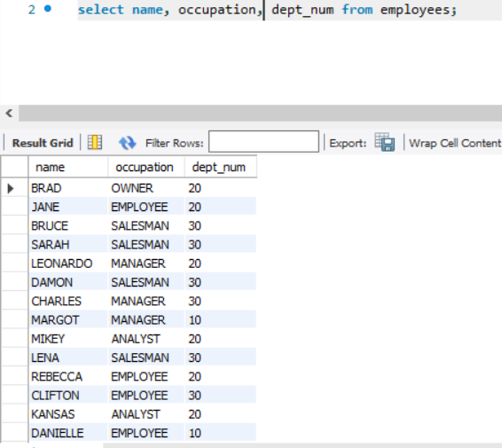

**2.** Show the number and name of each department.

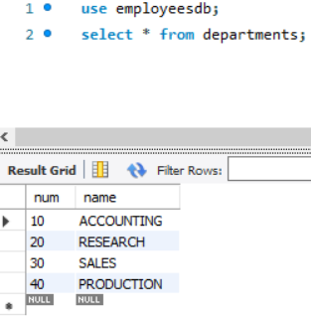

**3.** Show all the data of all the employees. 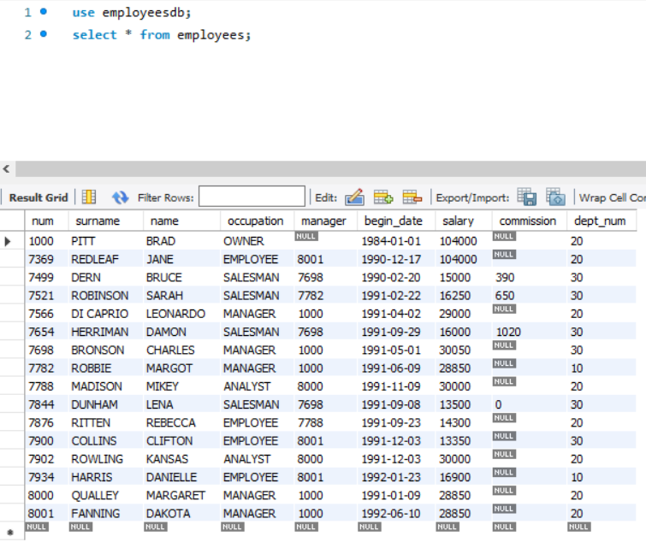

**4.** Employee data sorted by last name ascendent.

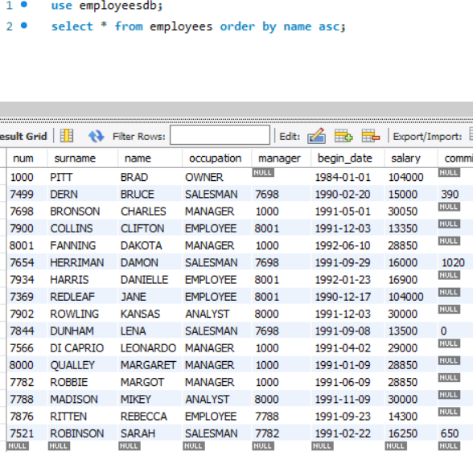

**5.** Employee data sorted by department number descending.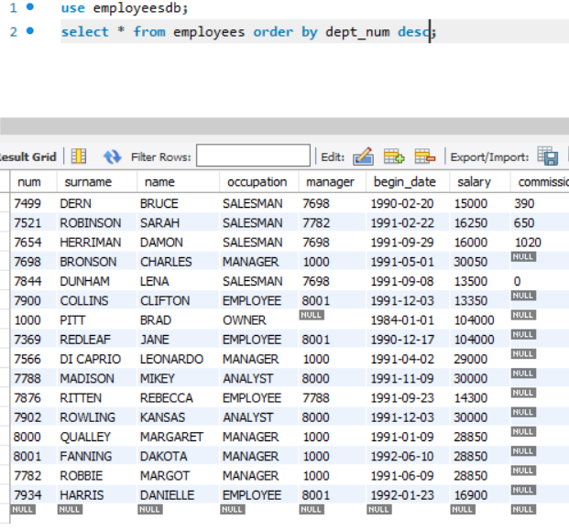

**6.** Employee data sorted by department number descending and, within each department, sort data by employee surname ascending.

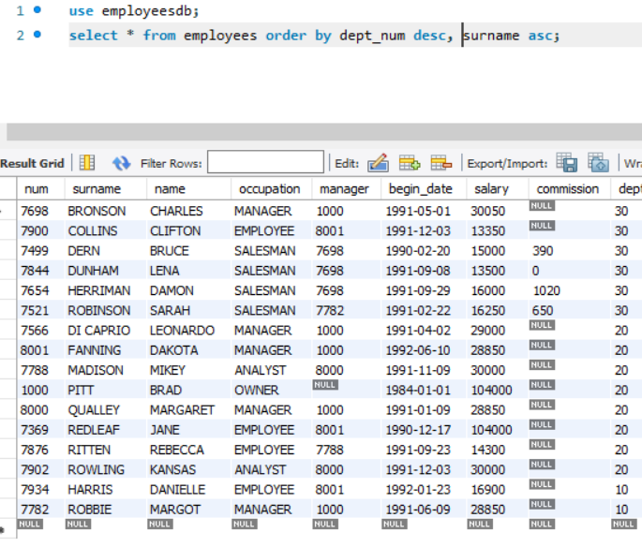

**7.** Show the data of the employees whose salary is greater than 20000.

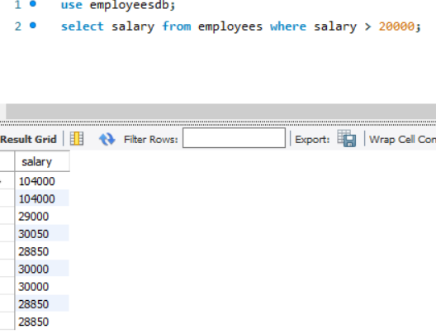

**8.** Show the data of the employees whose occupation is 'SALESMAN'.

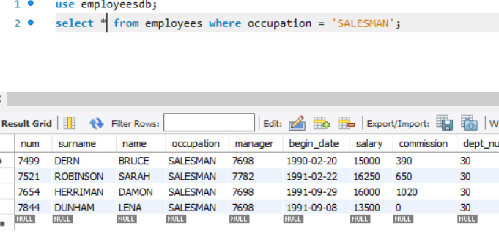

**9.** Select the surname and occupation of the employees of department number 20.

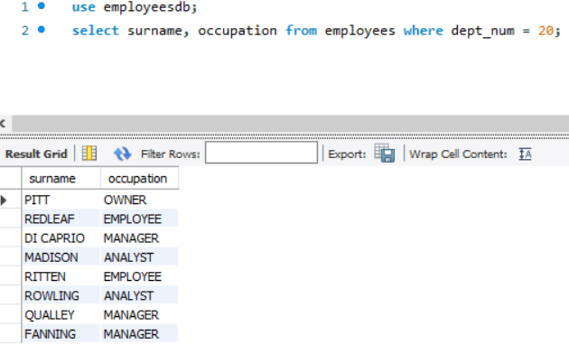

**10.** Select employees whose occupation is 'SALESMAN'. Show data sorted by surname.

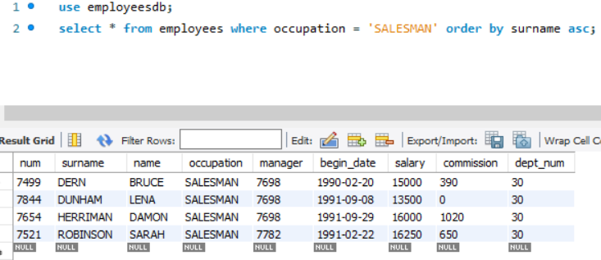

**11.** Show employees whose department is 20 or 30 and whose occupation is 'MANAGER'. Sort the result by dept_num descendent and surname ascendent.

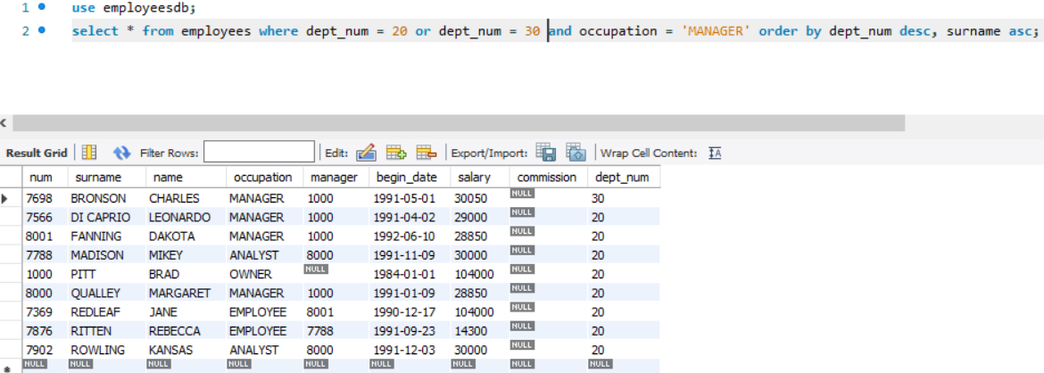

**12.** Show employees who have a salary greater than 20000 or who belong to the department number 20.

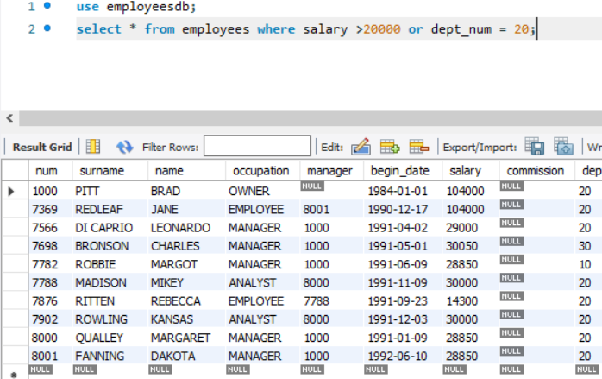

**13.** Show employees sorted by their occupation and by their surname.

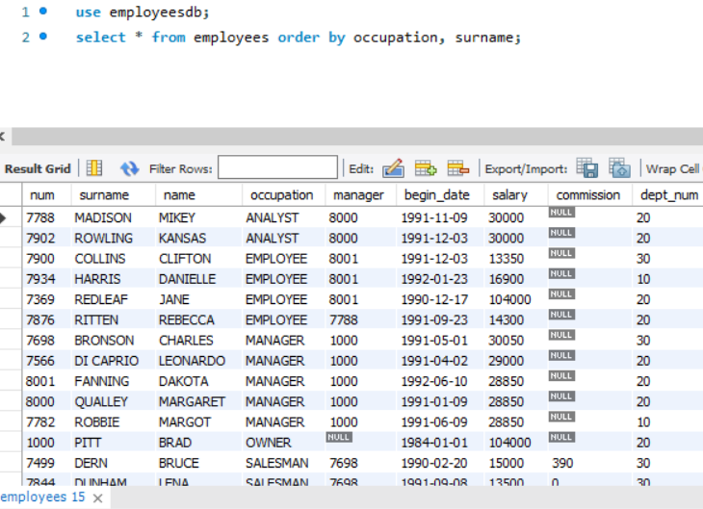

**14.** Select employees from the EMPLOYEES table whose surname starts with 'S'.

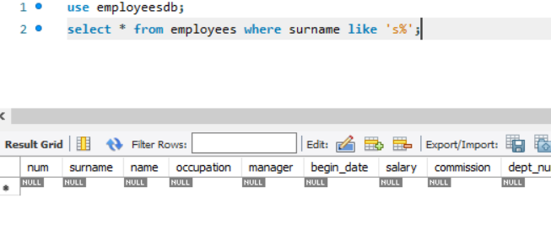

**15.** Select from the EMPLOYEE table those rows whose SURNAME  starts with 'C 'and the occupation has an 'E' in any position.

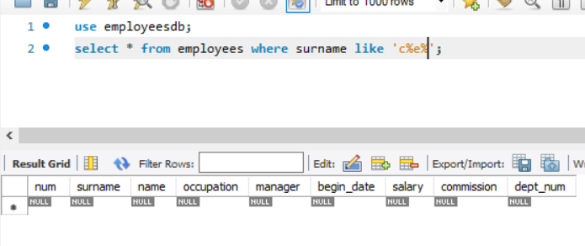

**16.** Select employees whose salary is between 10000 and 20000.

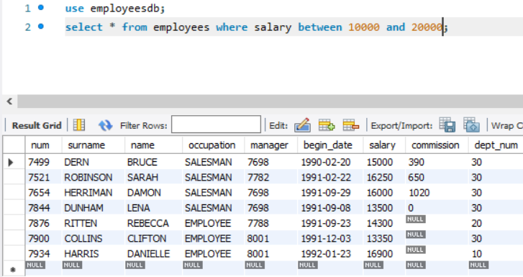

**17.** Obtain the employees whose occupation is 'SALESMAN' and have a commission exceeding 1000.

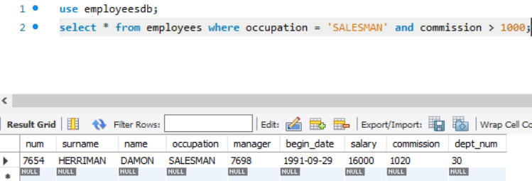

**18.** Number and surnames of the employees whose surname ends with 'S' and have a salary higher than 30000.

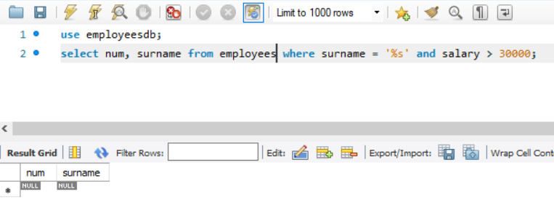

**19.** Data of the departments whose name starts with 'A' and ends with ‘G’.

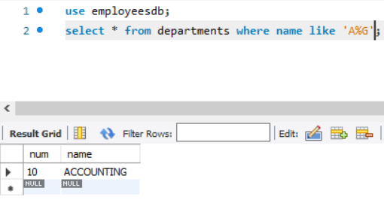

**20.** Show the surnames of the employees who do not have a commission (clue: is NULL).

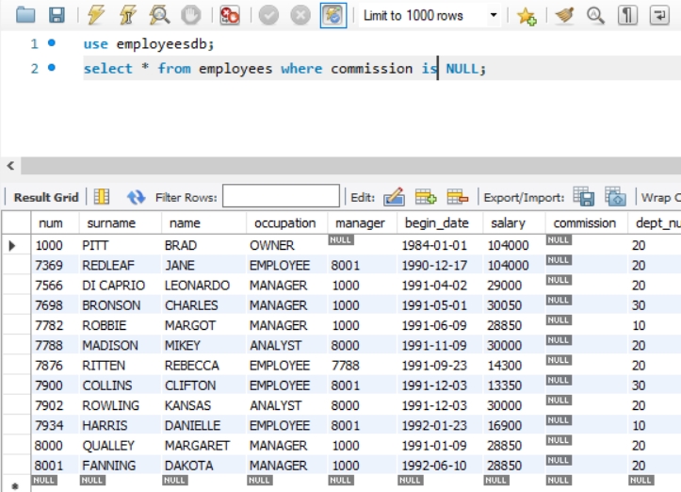

**21.** Show the surnames of the employees who do not have a commission and whose last name begins with 'H' (clue: is NULL).

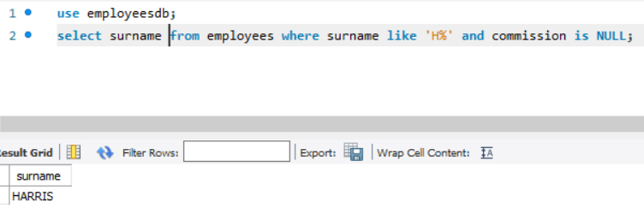

**22.** Show the surnames of the employees whose occupation is 'SALESMAN', 'MANAGER' or 'EMPLOYEE'.

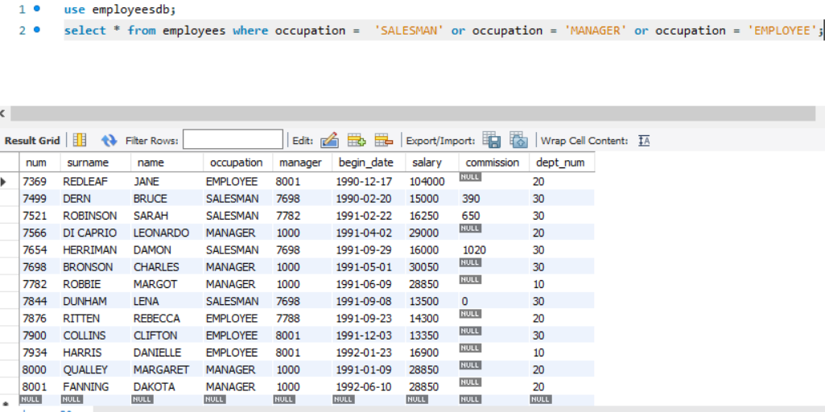

**23.** Show the surnames of the employees whose occupation is neither "MANAGER" nor "EMPLOYEE", and also have a salary higher than 20000.

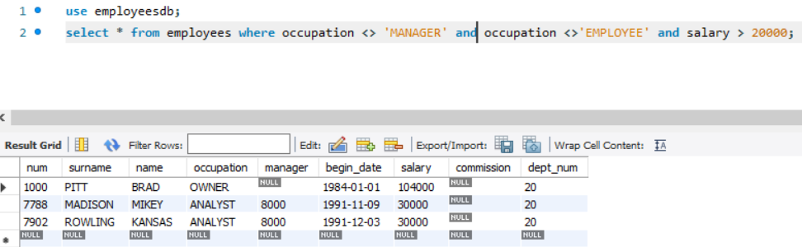

**24.** Select the surname, salary and department number of employees whose salary is greater than 20000 in departments 10 or 30.

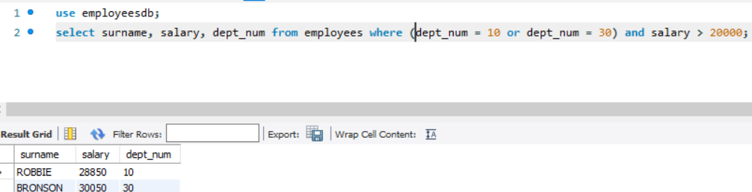

**25.** Show the surname and number of employees whose salary is not between 10000 and 20000.

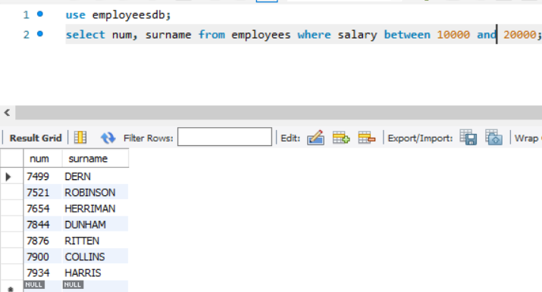

**26.** Get the surnames of all employees in lowercase.

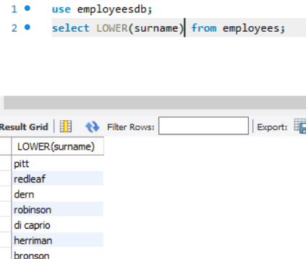

**27.** In a query, concatenate the name of each employee with his/her surname.

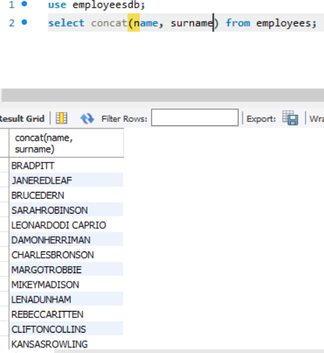

**28.** Show the surname and the length of the surname (function LENGTH) of all employees, sorted by the length of the surnames of the employees descending.

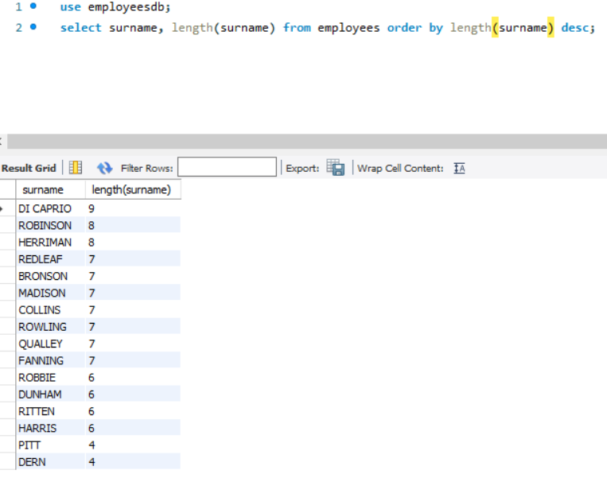

**29.** Show data of the employees whose surname have 4 characters and ends with ‘N’. Do a version using the function LENGTH and another one without it.

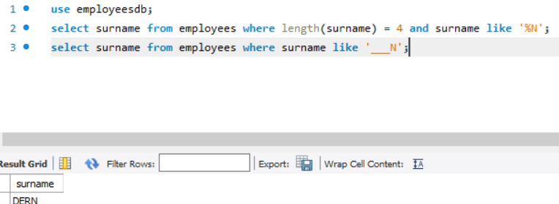

**30.** Obtain the years of recruitment of all employees (YEAR function) but without duplicated data. Order the results.

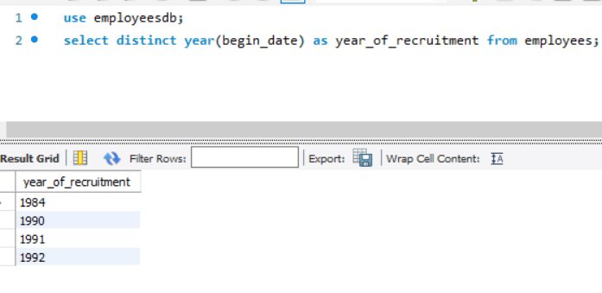

**31.** Show the data of the employees that have been recruited in the year 1992.

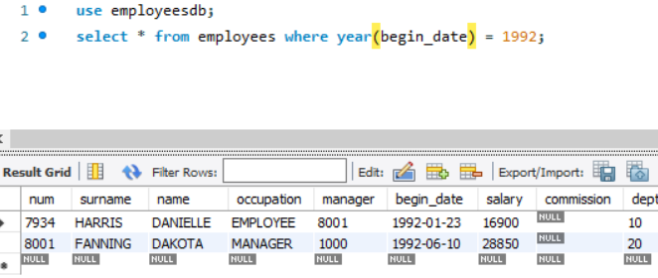

**32.** Show data of employees who have been recruited in the month of February of any year (function MONTHNAME).

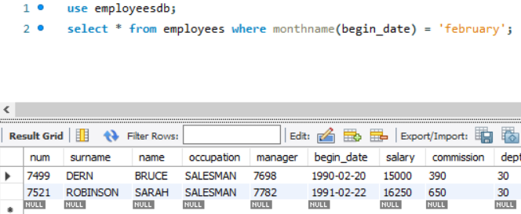

**33.** Show the data of the employees whose surname begins with 'R' and have been recruited in the year 1990.

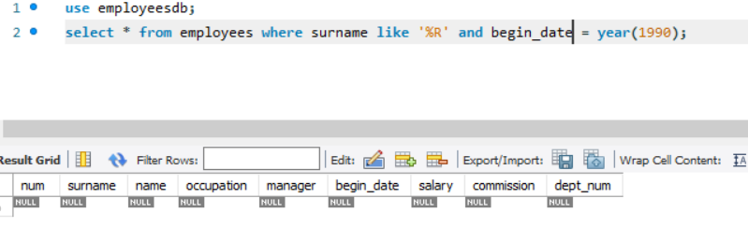

**34.** Show the name, surname, department name of the employees who have no commission (clue: is NULL).

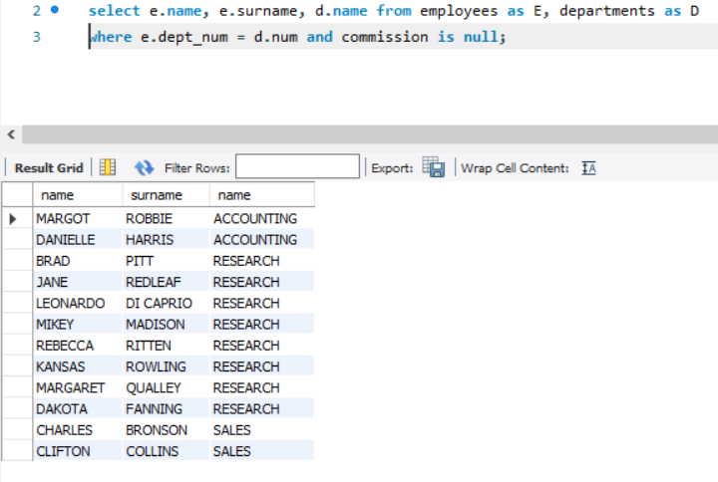

**35.**  Show the name, surname and occupation of employees with the name, surname and occupation of their managers. Columns must have different names and you must order it by the manager surname. Clue: Slide 32.

